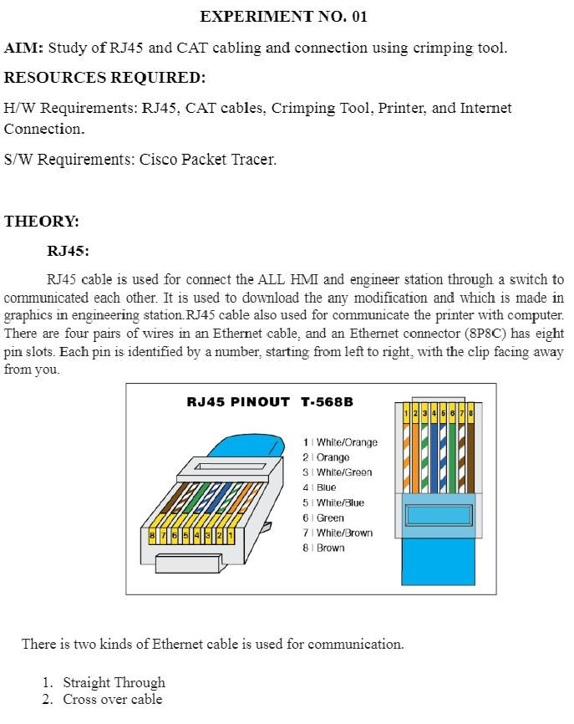EXP.NO:3B SHARMILEE B ROLL NO:231901049

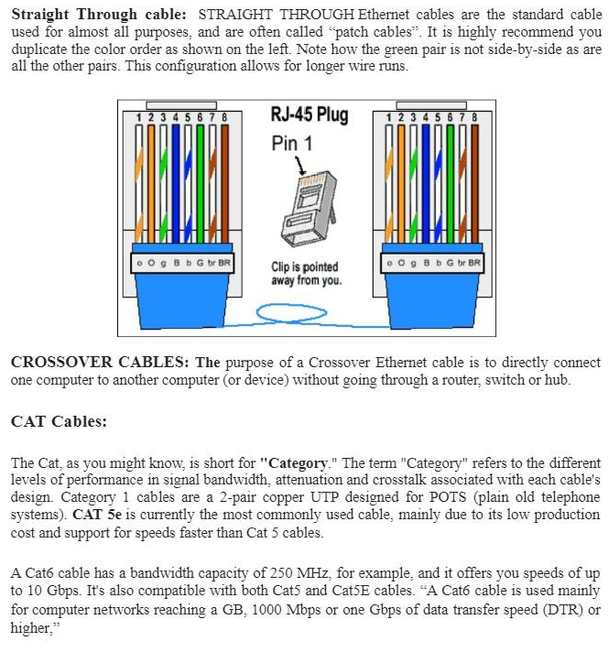

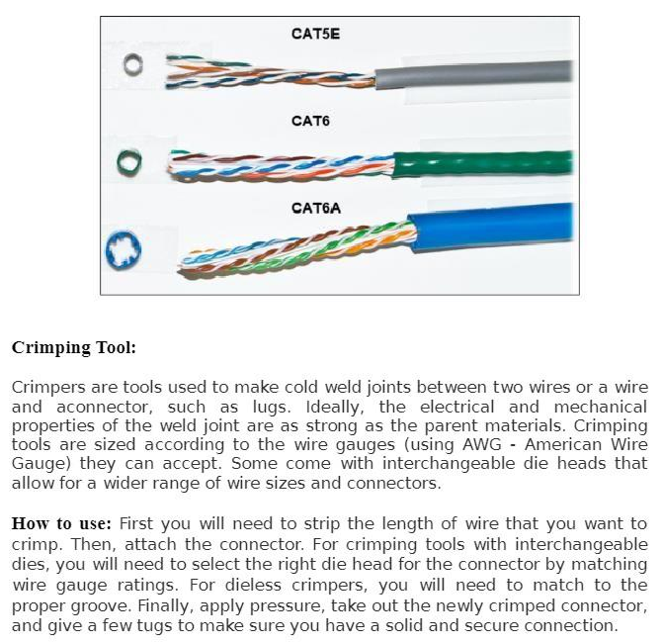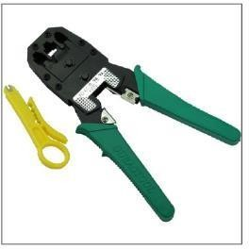

RESULT:

THE STUDY OF RJ45 AND CONNECTION USING CRIMPING CABLE HAS BEEN STUDIED SUCCESSFULLY.